COVID-19 Mortality Excess and Cost-Effective Analysis of Different Treatments

**Introduction**

COVID-19 pandemic has created a global public health crisis. Its impact on Mexico has been particularly severe. On March 21, 2021, the Mexican government reported 2,238,887 accumulated cases of COVID-19 and 203,210 deaths1, making Mexico the fourteenth country in the world in confirmed cases and the third in reported deaths.2

Excess mortality [pending explanation] from a disease is a useful and important measure for decision makers, since it allows them to evaluate different strategies aimed at modifying and mitigating this outcome. Currently, there are neither studies that have estimated the excess mortality from COVID-19, nor that attempt to evaluate the effectiveness of various strategies to reduce mortality from COVID-19. An important advantage of this approach is that it provides an opportunity to analyze policies that have not yet implemented and hence supports decision-making and planning

The aims of this analysis are twofold: 1) to estimate the COVID-19 specific mortality for Mexico’s population aged 45 years and older using relative survival methods; 2) to quantify the effectiveness, costs, and cost-effectiveness of different treatments that aim to reduce the COVID-19-specific mortality using a microsimulation model.

**Methods**

*Data*

We used data from the Mexican National Epidemiological Surveillance System. This dataset includes people tested for SARS-CoV-2 in Mexico and contains only data obtained from tests performed on people who were suspected of infection during stays in the medical units of the health sector5. We analyze data only for people with a positive test result, 45 years of age and older, who were hospitalized. We classify these patients by sex, age group, and whether they were intubated. The National Population Council demographic indicators provide background mortality rates for the Mexican population in 20206.

Pending information about costs and effects

*Relative Survival and specific probabilities of death*

We employ the relative survival and excess mortality analysis methodology. The methodology is appropriate when one is studying data on a cohort of people diagnosed with a disease as well as follow-up time and information on vital status but does not have definitive cause of death information.7

Relative survival is expressed as a time-specific ratio between the survival of the cohort analyzed $S_{O}(t)$ and the expected survival of the population $S_{p}(t)$ normally obtained from population mortality information. Relative survival is defined as .7,8 The methodology also allows one to report the overall hazard $λ_{O_{i}}(t)$ over time for the cohort analyzed, which can be written as the sum of the disease-specific hazard $λ_{E_{i}}\left(t\right)$ and the average background population hazard 7.

Disease-specific hazard or “excess-hazard” estimates allow one to compute disease-specific mortality rates and then to extrapolate intervention effects derived from RCTs (i.e., hazard rate ratios) in computing survival in the presence of interventions. By deriving the disease-specific mortality rate ($μ_{Dis}$) and the background mortality rate by sex and age ($μ_{SA}$) from $λ_{E_{i}}\left(t\right)$ and $λ_{P_{i}}(t)$, and assuming the hazard is an additive function of each specific mortality rate, the overall mortality rate is then defined as 9:

Incorporating the effect of an intervention, such as a pharmacological treatment for a disease then involves modifying $μ_{Dis}$. Published Hazard Ratios from clinical trials $(HR_{CT}$), when estimated on the disease-specific hazards, are then applied to the disease-specific mortality rate $μ_{Dis}$ which in turn alters the overall total mortality rate $μ_{Ovall}$: $μ_{Dis}^{*}=μ_{Dis}*HR_{CT}$

$$μ_{Ovall}^{*}=μ_{Dis}^{*}+μ_{SA }$$

Pending: Edition and a more detailed description

*Decision Model*

Using the population of hospitalized Mexican patients testing positive for COVID-19 who were age 45 and older as our cohort along with information on expected mortality in the general population aged 45 and older in 2020, we estimated disease-specific (${\overline{λ}}_{Dis}$) and background hazards for sex and age (${\overline{λ}}_{SA}$) over a 50day follow-up period from time of diagnosis. To do so, we employed modified versions of functions from the *relsurv*10 package in R. These estimates allowed us to calculate daily disease-specific and background mortality probabilities by age group and sex assuming an exponential distribution of the hazard rate at a specific time:

$$P(Die)=1-\exp\left(- {\overline{λ}}_{Ovall}\right)$$

$$P\left(Die from Covid | Die\right)= P\left(Die\right)*\frac{{\overline{λ}}_{Dis}}{{\overline{λ}}_{Dis}+{\overline{λ}}_{SA} })$$

$$P\left(Die of other causes | Die\right)= P\left(Die\right)*\frac{{\overline{λ}}_{SA}}{{\overline{λ}}_{Dis}+{\overline{λ}}_{SA} })$$

We then incorporated these outputs into a decision-analytic microsimulation model which follows individuals infected with COVID-19 in Mexico for 50 days. The model also evaluates alternative treatment strategies by incorporating the effects of treatments that have demonstrated mortality reductions for people with Covid-19: Dexamethasone11, Remdesivir12 and Remdesivir with Baricitinib13. The overall Hazard Ratio of the clinical trials $(oHR_{CT})$ of these treatments was applied to obtain the COVID-19 specific death probabilities under the effect of different drugs:

Because the hazard ratio for Remdesivir and Baricitinib is reported in comparison to a group treated with Remdesivir, the effect of Baricitinib is applied to ${\overline{λ}}_{Dis with Remd}$ which is computed as defined above.

$$P(Die_{Remd})=1-\exp\left(- {\overline{λ}}_{Ovall}*oHR_{Remd}\right)$$

$$P(Die_{Remd \& Bari})=1-\exp\left(- {\overline{λ}}_{Ovall}*oHR_{Remd} *oHR_{Bari}\right)$$

$$P(Die_{Dexa})=1-\exp\left(- {\overline{λ}}_{Ovall}*oHR_{Dexa}\right)$$

The microsimulation model utilized in this analysis is an adaptation of the state-transition microsimulation algorithm proposed for modeling for health decision sciences14. The model includes two health states: Detected with COVID-19 infection during hospitalization and Dead. The model tracks whether those who die do so because of COVID-19 or from other causes.

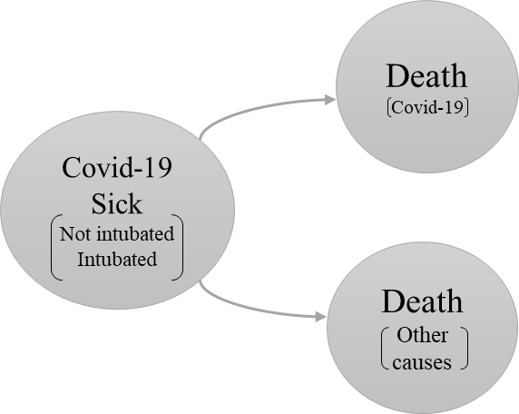

Figure 1 Model structure

Pending: Edition and a more detailed description

*Cost-effectiveness and Sensitivity analysis*

Because Dexamethasone is not recommended for non-intubated patients and Remdesivir is a drug that has shown more efficacy in less critical states, the simulated population was divided into two cohorts as the feasible decision alternatives are different in these two groups: Patients who were hospitalized without intubation and patients who were hospitalized and intubated. We carry out a cost-effectiveness analysis for the following strategies:

Patients hospitalized without intubation

1. Treat with Remdesivir
2. Treat with Remdesivir and Baricitinib
3. No treatment

Patients hospitalized and intubated

1. Treat with Dexamethasone
2. No treatment

Incremental Cost-Effectiveness Ratio (ICER) is incorporated to determine the best strategy for each cohort. The ICER estimation was carried out with *dampack*15package*.* The cost-effectiveness analysis was developed with a probabilistic sensitivity analysis to incorporate uncertainty in the information on the effectiveness of treatments and hospital costs. Supplemental material of this document includes the parameters utilized in the model.

*Costs*

Costs includes expected daily costs by hospitalization and an estimation of the treatment costs based on information reported by the Mexican Institute of Social Security 16. All costs are reported in Mexican pesos.

*Effects*

Effectiveness is expressed in Quality Adjusted Life Years (QALYs) by strategy. To calculate this, we take the people that survived after the simulated 50 days and added the expected years of life according to their sex and age.

Pending: Go deeper into this explanation

All calculations, models and graphs were done using R,3 and Rstudio software.4

**Results**

Pending: Cohort characteristics data table

*COVID-19 specific hazard*

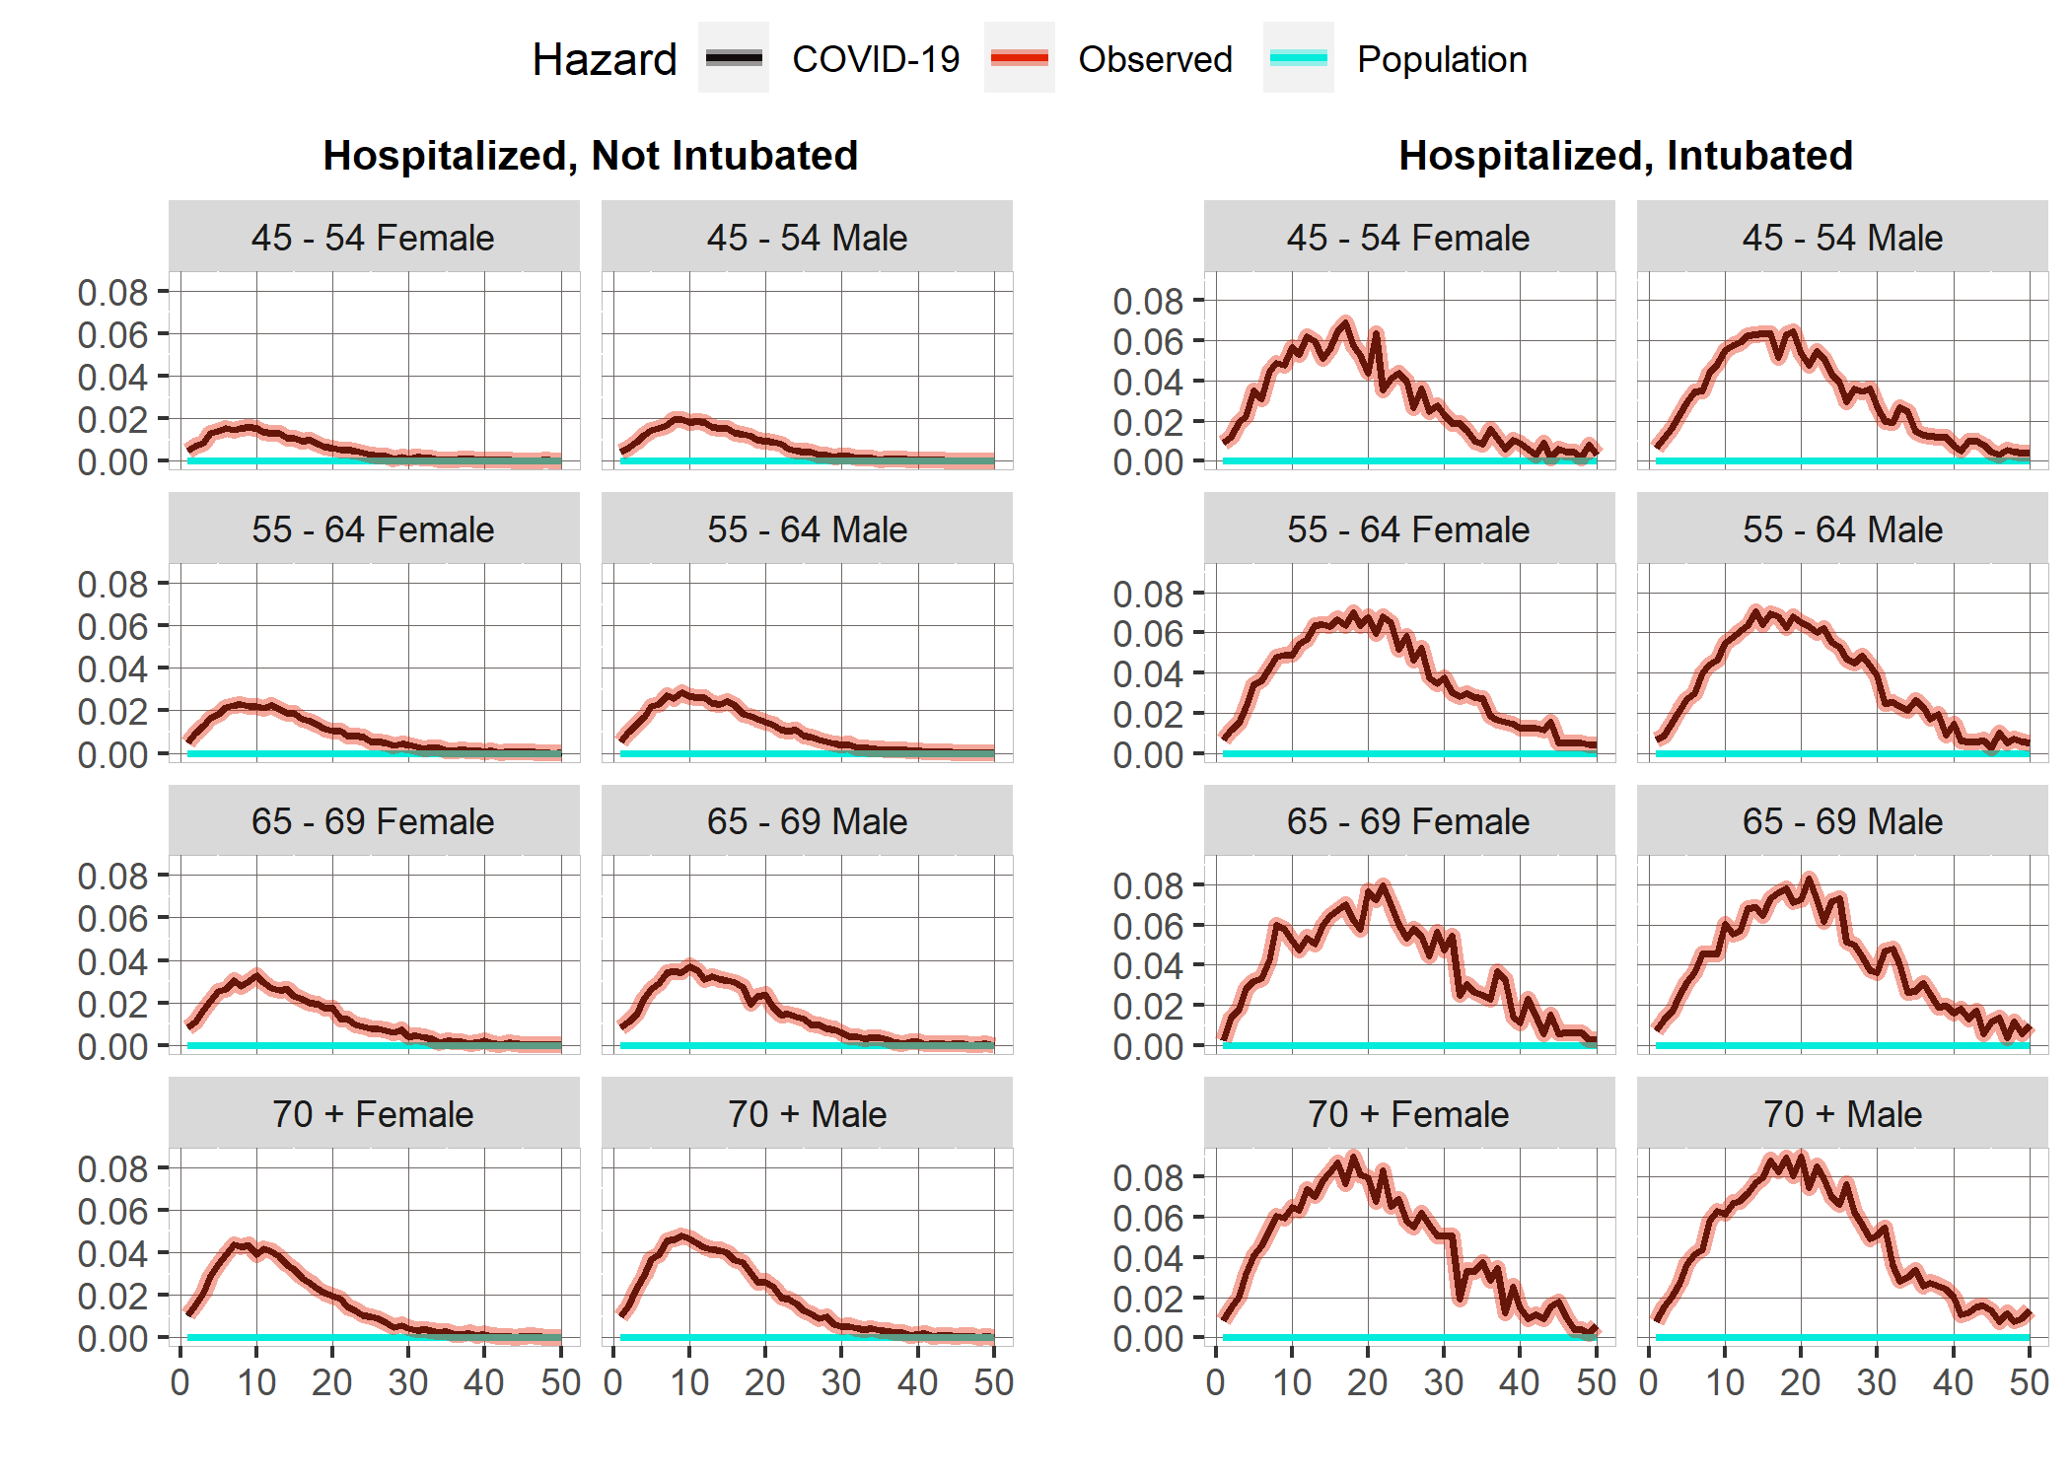

Figure 2: COVID-19 Daily hazards by cohort, age and sex group. Source: Author´s own creation with information published by Mexico´s Ministry of Health.

The results show us that the COVID-19 specific hazard practically represents the total hazard, since the daily background population mortality rates are near 0. The highest hazard is around day 10 for hospitalized people, while in the intubated cohort, the high hazard rates remain for more days, extending beyond 20 days for all age groups. For the hospitalized cohort hazard increases at higher ages and is systematically higher for Male sex. Practically all observed hazard decreases to the expected population mortality level after day 40.

However, hazards are practically double for the intubated cohort. Also, the intubated cohort's hazards are very similar after 55 years, and the differences by sex are much less notable. The effect of COVID-19 does not disappear for the last age group, and even on day 60, the mortality levels are higher than expected.

*Cost-effectiveness Analysis*

The cost-effectiveness analyses presented come after having carried out a probabilistic sensitivity analysis with 1,000 sets of parameters. The distribution of parameters is in the supplemental material.

Pending: Edition and a more detailed description

*Hospitalized cohort*

If no treatment is applied, the expected life years are 7.54. When the population is treated with Baricitinib and Remdesivir is applied, the expected life years gained are 2.08.

|  |  |  |  |  |  |
| --- | --- | --- | --- | --- | --- |
| **Cost-Effectiveness Analysis: Hospitalized** | | | | | |
| Strategy | Cost | Effect | Incremental Cost | Incremental Effect | ICER |
| *No Treatment* | $317,932.60 | 7.542261 | - | - | - |
| *Remdesivir and Baricitinib* | $488,107.00 | 9.629469 | $170,174.40 | 2.087208 | $81,532.0754 |
| *Remdesivir* | $406,372.00 | 8.548145 | - | - | - |

Figure 3: ICERs of the three different strategies for the hospitalized cohort

The results only display incremental costs, effects and ICER´s for the “No treatment” and “Remdesivir and Baricitinib” strategies because “Remdesivir” is a weakly dominated strategy as can be seen in the efficient frontier, which implies that the “Remdesivir and Baricitinib” strategy is always chosen if the willingness to pay increases above the “No treatment” limit.

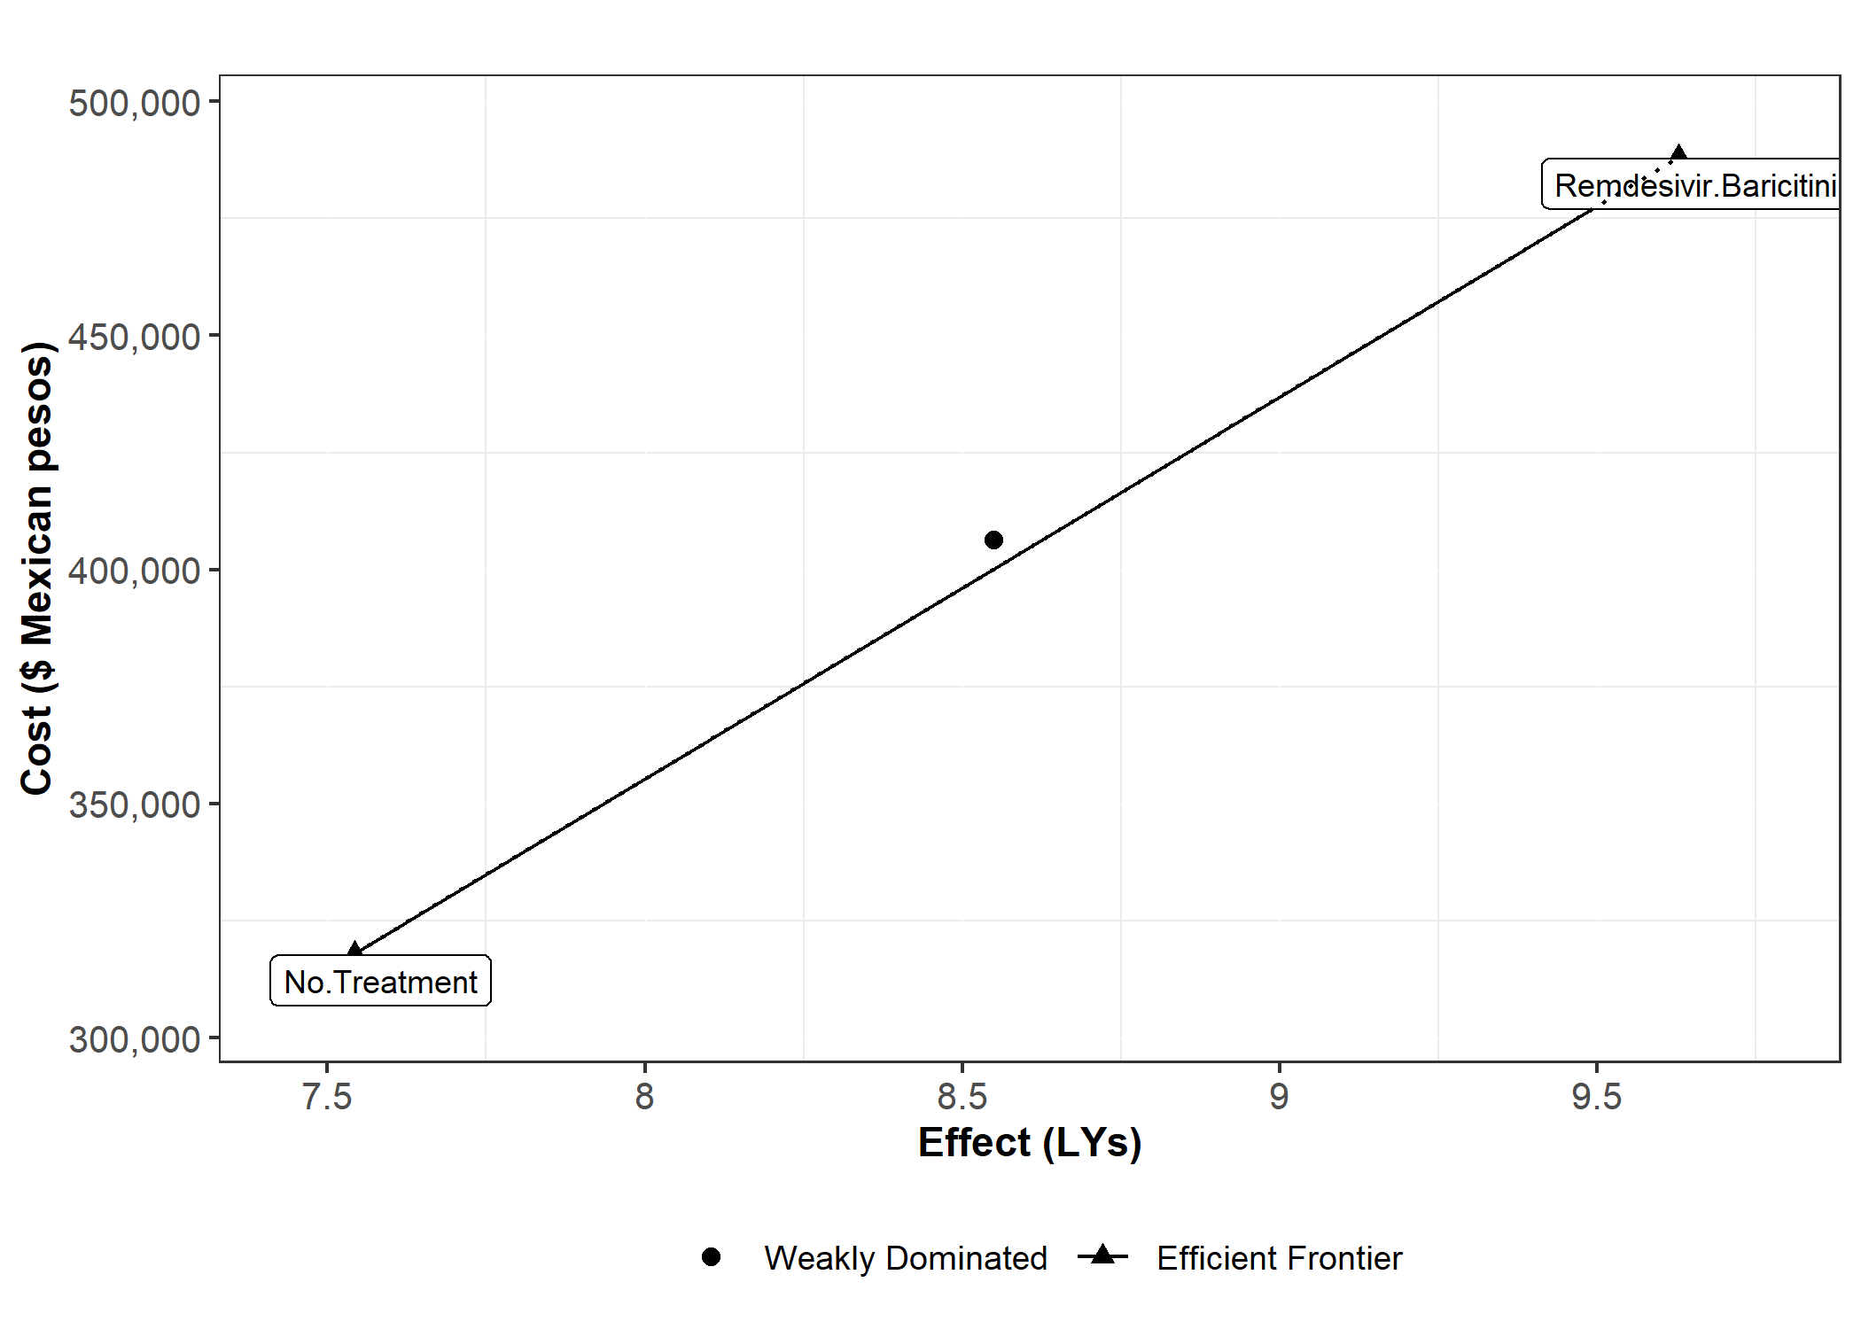

Figure 4: Efficient frontier of strategies for the hospitalized patient cohort

If the willingness to pay surpasses $87,922.64 Mexican pesos per life-year, gained “Remdesivir and Baricitinib” strategy has a greater probability of being more cost-effective than the other two strategies. Below this point, “No treatment” is probably more cost-effective.

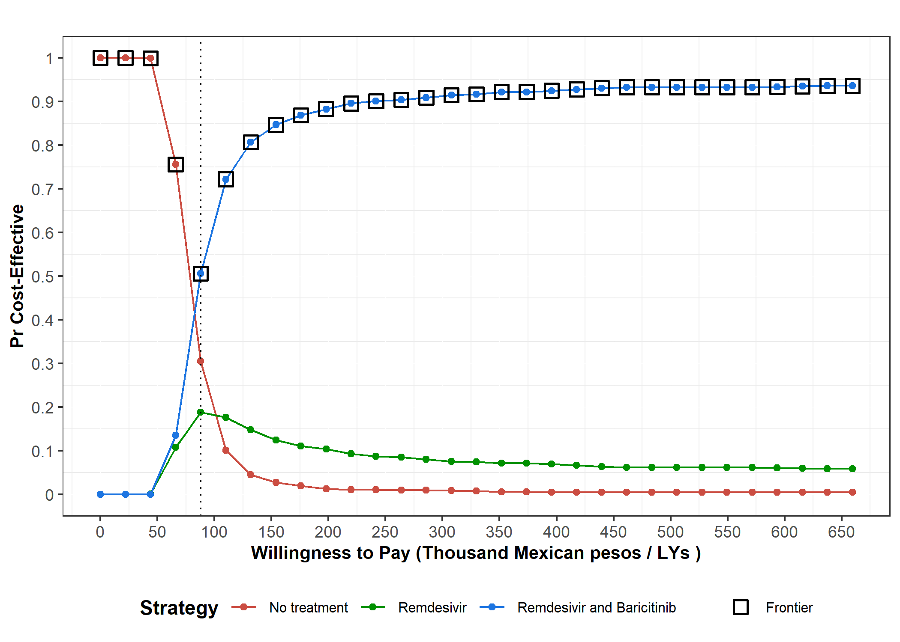

Figure 5: Probability of a strategy for hospitalized patients of being cost-effective under different willingness to pay. Dotted line indicates the threshold where one strategy outperforms another in probability.

Pending: Edition and a more detailed description

*Intubated cohort*

The expected Life Years gained by dexamethasone are 1.8. The vast majority of dexamethasone costs come from the increase in individuals who survived the treatment and who saw their hospital costs increase. The price of the drug is meager (approximately 4 Mexican pesos).

|  |  |  |  |  |  |
| --- | --- | --- | --- | --- | --- |
| **Cost Effectiveness Analysis: Intubated** | | | | | |
| Strategy | Cost | Effect | Incremental Cost | Incremental Effect | ICER |
| *No Treatment* | $923,677.90 | 2.07726 | - | - | - |
| *Dexamethasone* | $1,200,217.20 | 3.898768 | $276,539.30 | 1.821508 | $151,818.878 |

Figure 6: ICERs of the three different strategies for the intubated patient cohort

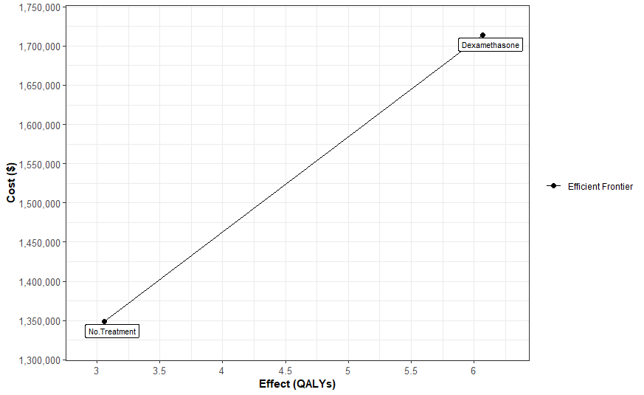

Figure 7: Efficient frontier of strategies for the intubated patient cohort

In this case, “Dexamethasone” strategy is more cost-effective when the willingness to pay increases over $153,8646 per life year gained.

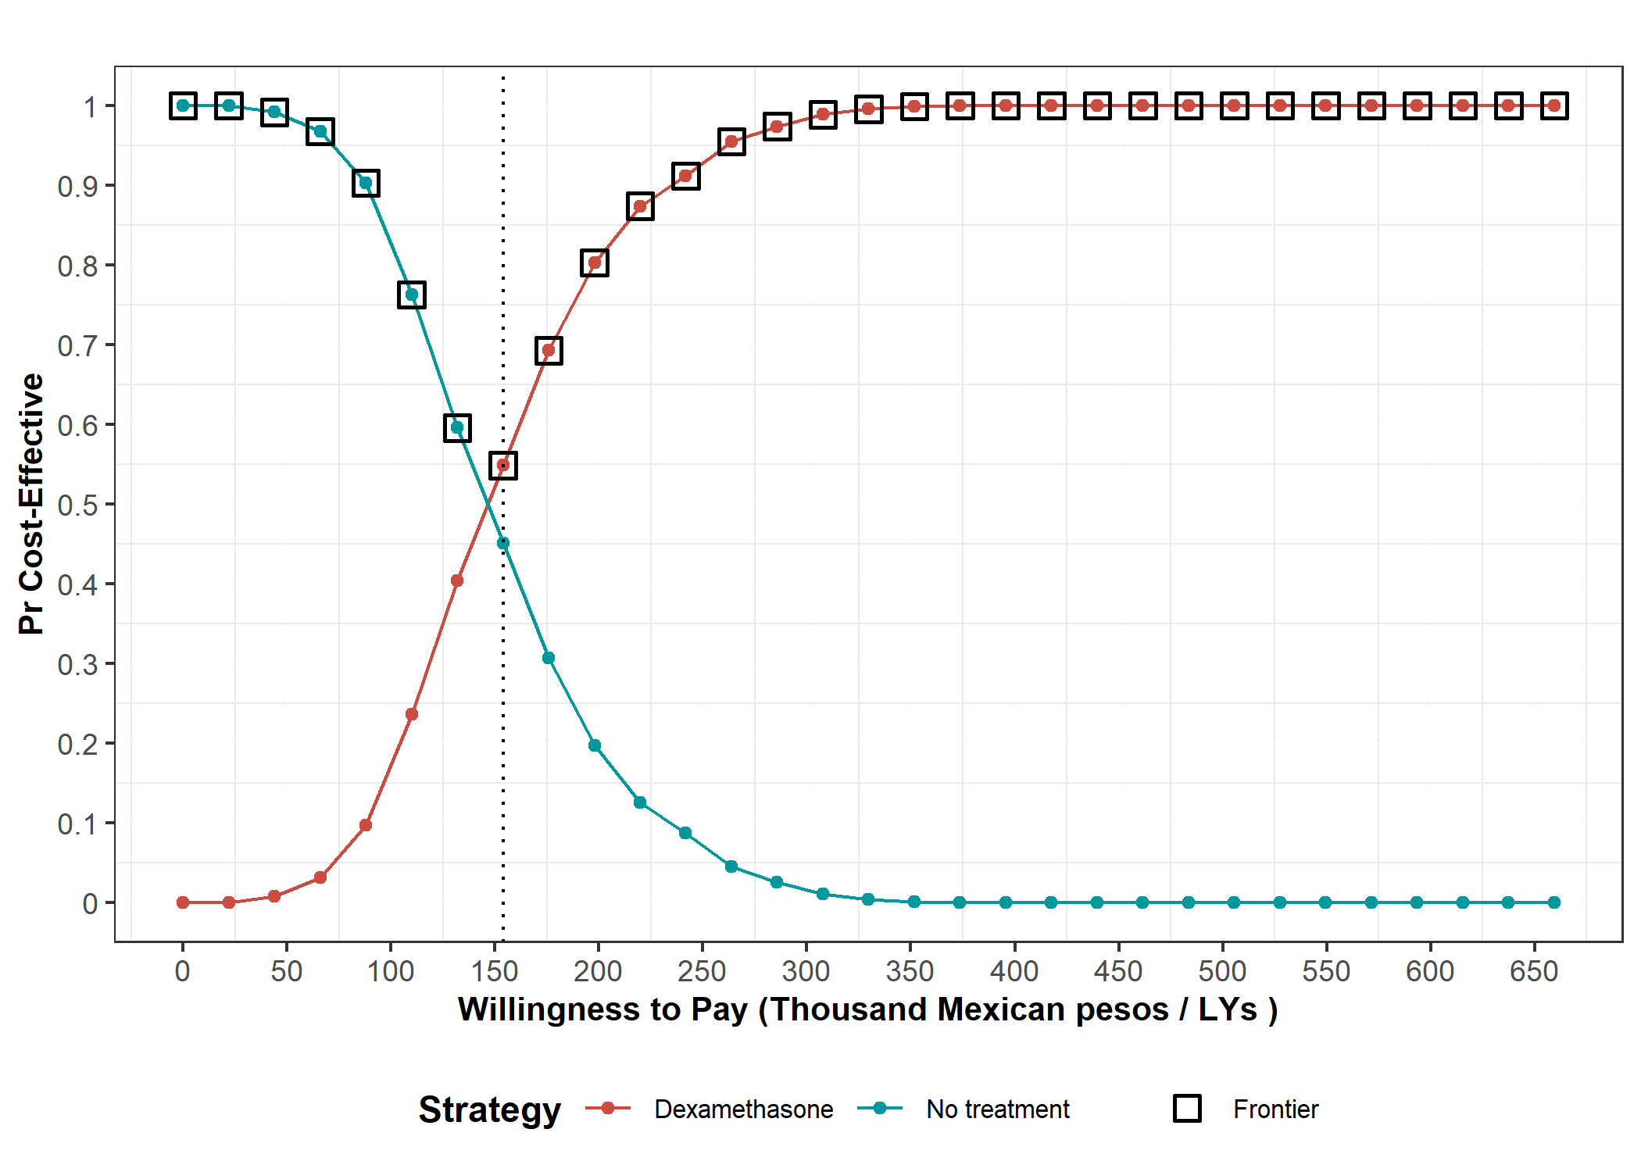

Figure 8: Probability of a strategy for intubated patients of being cost-effective under different willingness to pay. Dotted line indicates the threshold where Dexamethasone strategy outperforms No treatment in probability.

Pending: Edition and a more detailed description

**References**

1 Secretaria de Salud. Informe Técnico Diario COVID-19 MÉXICO. 2020. https://www.gob.mx/cms/uploads/attachment/file/593517/Comunicado_Tecnico_Diario_COVID-19_2020.11.19.pdf.

2 John Hopkins University. COVID-19 Dashboard by the Center for Systems Science and Engineering (CSSE) at Johns Hopkins University (JHU). 2020. https://coronavirus.jhu.edu/map.html (accessed Dec 9, 2020).

3 R Core Team. R: A Language and Environment for Statistical Computing. 2013. http://www.r-project.org.

4 Rstudio Team. RStudio: Integrated Development for R. 2020. http://www.rstudio.com/.

5 Secretaría de Salud. Información referente a casos COVID-19 en México. Bases datos COVID 19 en México. 2020; published online Nov 19. https://datos.gob.mx/busca/dataset/informacion-referente-a-casos-covid-19-en-mexico/resource/3d7fb4a8-5763-4dba-a23f-a20edc7783f7 (accessed Dec 9, 2020).

6 Consejo Nacional de Población (CONAPO). Proyecciones de la Población de los Municipios de México, 2015-2030. 2019; published online Sept 22. https://www.gob.mx/conapo/documentos/proyecciones-de-la-poblacion-de-los-municipios-de-mexico-2015-2030 (accessed Dec 9, 2020).

7 Pohar Perme M, Klemen P. Pohar Perme, Pavlič - 2018 - Nonparametric relative survival analysis with the R package relsurv.pdf. *J Stat Softw* 2018; **87**. DOI:https://doi.org/10.18637/jss.v087.i08.

8 EDERER F, AXTELL L, CUTLER S. The relative survival rate: a statistical methodology. *Natl Cancer Inst Monogr* 1961; **6**: 101.

9 Alarid-Escudero F, Kuntz KM. Potential Bias Associated with Modeling the Effectiveness of Healthcare Interventions in Reducing Mortality Using an Overall Hazard Ratio. *Pharmacoeconomics* 2020; **38**: 285–96.

10 Pohar Perme M. Package ‘ relsurv ’. 2018. https://cran.r-project.org/web/packages/relsurv/relsurv.pdf.

11 The RECOVERY Collaborative Group. Dexamethasone in Hospitalized Patients with Covid-19 — Preliminary Report. *N Engl J Med* 2020; : 1–11.

12 Beigel JH, Tomashek KM, Dodd LE, *et al.* Remdesivir for the Treatment of Covid-19 — Final Report. *N Engl J Med* 2020; **383**: 1813–26.

13 Marconi VC, Palacios GMR, Hsieh L, *et al.* Baricitinib plus Remdesivir for Hospitalized Adults with Covid-19. 2020; : 1–13.

14 Krijkamp EM, Alarid-Escudero F, Enns EA, Jalal HJ, Hunink MGM, Pechlivanoglou P. Microsimulation Modeling for Health Decision Sciences Using R: A Tutorial. *Med Decis Mak* 2018; **38**: 400–22.

15 Alarid-Escudero F, Krijkamp EM, Pechlivanoglou P, *et al.* A need for change! A coding framework for improving transparency in decision modeling. *Pharmacoeconomics* 2019; **37**: 1329–1339.

16 H. Consejo Técnico. Acuerdo relativo a la Aprobación de los Costos Unitarios por Nivel de Atención Médica actualizadas al año 2021. México: Diario Oficial de la Federación, 2020.

**Appendix**

|  |  |
| --- | --- |
| **Table 1: Parameter microsimulation model: Hospitalized Cohort** | |
| **Parameters** | **Value** |
| *Number of individuals* | 200,693 |
| *Time horizon* | 50 days |
| *Number of states* | 3 |
| *Name of states* | Cov-19 + |
| Cov-19 Dead |
| Other causes Dead |
| *Annual discount rate for costs* | 0.0165 |
| *Annual discount rate for efectiveness* | 0.0165 |
| **Daily healthcare costs** | |
| *Hospitalized COVID-19 patient* | Gamma distribution: ꓗ = 8, θ = 1159 |
| *Dead patient* | 0 |
| **Intervention daily costs** | |
| *Remdesivir* | $6,188.00 |
| *Baricitinib* | $3,672.00 |
| **Intervention Effect** | |
| *Remdesivir* | Lognormal distribution: μ = 0.73, σ = 0.17 |
| *Baricitinib* | Lognormal distribution: μ = 0.65, σ = 0.26 |
| *All monetary amounts are expressed in Mexican pesos | |

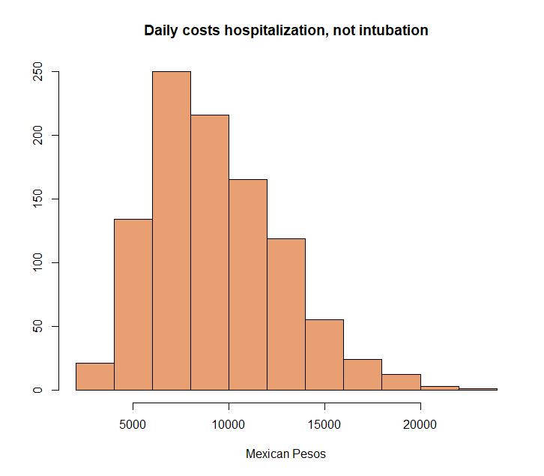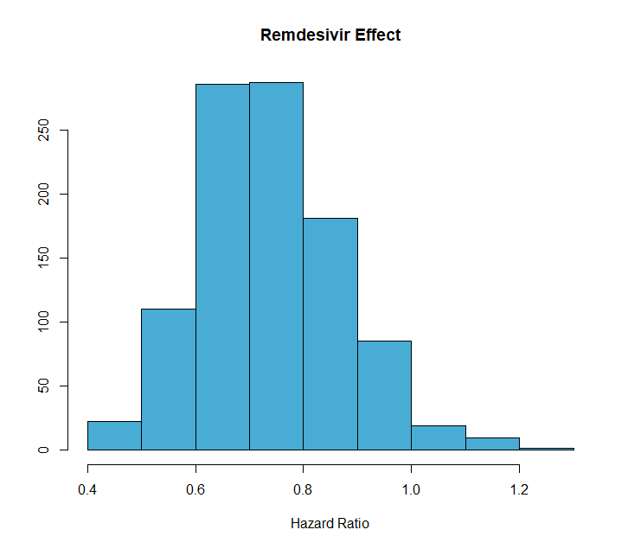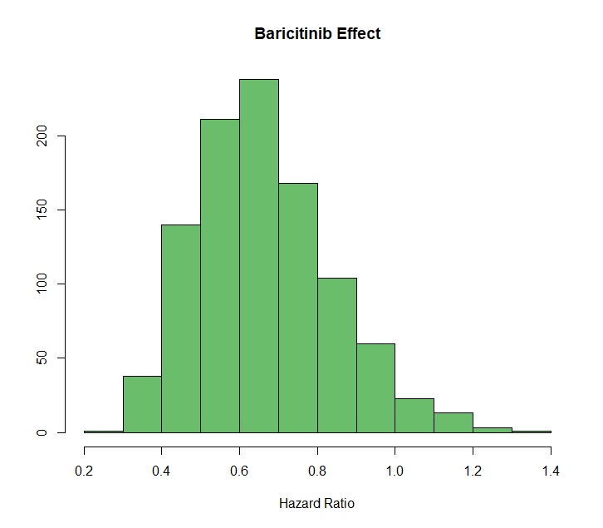

|  |  |
| --- | --- |
| **Table 2: Parameter microsimulation model: Intubated Cohort** | |
| **Parameters** | **Value** |
| *Number of individuals* | 38,884 |
| *Time horizon* | 50 days |
| *Number of states* | 3 |
| *Name of states* | Cov-19 + |
| Cov-19 Dead |
| Other causes Dead |
| *Annual discount rate for costs* | 0.0165 |
| *Annual discount rate for efectiveness* | 0.0165 |
| **Daily healthcare costs** | |
| *Intubated COVID-19 patient* | Gamma distribution: ꓗ = 8, θ = 5518.87 |
| *Dead patient* | 0 |
| **Intervention daily costs** | |
| *Dexamethasone* | $4 |
| **Intervention Effect** | |
| *Dexamethasone* | Lognormal distribution: μ = 0.64, σ = 0.11 |
| *All monetary amounts are expressed in Mexican pesos | |

